Chapter 4 Draft

**Abstract**

**Introduction**

Hypoxia is common in coastal and estuarine waters and is expected to intensify with global warming (Breitburg et al., 2018). Between anthropogenic influence on nearshore waters and the natural dynamics of shallow, partially enclosed water bodies, hypoxia often co-occurs with other stressors such as high temperature, carbon dioxide (CO2) acidification, and pollutants (Gruber, 2011). Along the Northeast United States coast, stratification and productivity associated with high temperatures in spring and summer cause hypoxic and eutrophic zones to form and great fluctuations in dissolved oxygen (DO) on diel to monthly time scales (O’Donnell et al., 2004; Baumann and Smith, 2018; Testa et al., 2018). While fish species that currently live in such areas tend to have mechanisms to cope with periods of hypoxia (Farrell and Brauner, 2009; Zhu et al., 2013; Baumann, 2019), these do not necessarily confer tolerance of longer durations. Fishes that spawn in the spring and summer face the additional threat of experiencing hypoxia during the particularly sensitive early life stages. Embryos and young larvae rely largely on diffusion for oxygen uptake and lack well-developed mechanisms, such as high surface area gills, to meet oxygen demands in low DO water and are not mobile enough to escape hypoxic zones. Mortality can result directly from severe hypoxia or indirectly from reduced growth increasing susceptibility to predation. Even fish that survive may incur sublethal effects with lifelong consequences for growth, development, and reproduction. Understanding the mechanistic responses to hypoxia can help predict how tolerant fishes will be to intensifying hypoxic zones and how their sensitivity to predation and additional environmental stressors could change.

When targeted conservation action is desired, population-level risks associated with stressors are important to quantify because this level is most often used for management. Much research on stressor effects uses laboratory experiments to measure physiological responses, but additional steps can be taken to elucidate how these translate to life history outcomes such as recruitment and reproductive investment in the next generation. Models that connect physiological and energetic mechanisms of stressor effects to life history create widely applicable tools that can be used to make population-level predictions. Dynamic Energy Budget (DEB) modeling is a bioenergetic framework designed to bridge multiple levels of biological organization in assessing stressor effects in a vast variety of species (Kooijman, 2010; AmP, 2023). The model follows energy allocation, in the form of suborganismal metabolic fluxes, and how it leads to life history outcomes such as growth rate, reproductive output, and survival, using physical and biological concepts that are generalizable to most species (Jusup et al., 2017). It accounts for differences in the energy budget at each stage to allow modeling of life stage transition timing and stage-specific mortality (Kooijman, 2010). DEB theory is often used to connect experimental observations of multiple stressor effects to both the underlying energetic mechanisms (Kooijman, 2017) and life history outcomes that feed into population dynamics (Martin et al., 2013; Smallegange et al., 2017). These capabilities make DEB theory an excellent tool for enhancing the utility of experimental data in conservation and management (Lavaud et al., 2021).

but also be incorporated into larger models of other stressor impacts such as acidification and contaminant effects. This type of work could be continued for *M. menidia* as a model species and ecologically important fish, or it could be modified to other species for which similar data are available.’

Topic: This is DEBkiss and how it is different from standard DEB, and why we chose it

Like the standard DEB model (Kooijman, 2010), the DEBkiss framework specifies the inputs, relative allocation, and sinks of energy and mass in a general enough manner to be applied to most animals, although it does not apply to other forms of life such as plants. However,

Topic: This is wat we know about menidia menidia hypoxia response

Topic: This is how we expect DEBkiss model to help us understand hypoxia effects (including approach and hypotheses, which DEB processes could be responsible)

**Rationale – why do we want to do this work?**

*Rationale for this specific approach*

~~Hypoxia is common in the early life environment of~~ *~~Menidia menidia~~* ~~and is expected to intensify with global warming (Cadigan and Fell, 1985; Breitburg et al., 2018).~~ Currently the species is tolerant enough that population declines are not a concern, but without knowledge of the mechanisms of early life impacts it is hard to predict whether this will change under increased hypoxia and coinciding stressors (Baumann, 2019). It is important to unify the multiple physiological responses we have documented in order to quantify population-level consequences, and a DEB model builds the foundation to do so (Lavaud et al., 2021).

A primary mechanism by which the fish energy budget is thought to be impacted by hypoxia is reduced food consumption (Chabot and Dutil, 1999; Thomas et al., 2019). However, consumption effects do not explain the observed hypoxia impacts on *M. menidia* hatch survival and size (Cross et al., 2019) because embryos do not feed. For this reason it is necessary to put a particular focus on the early life energy budget and attempt to identify alternative DEB processes in *M. menidia* that are impacted by hypoxia.

*Big picture rationale*

Developing a model that incorporates physiological and energetic mechanisms of hypoxia effects creates a widely applicable tool that can be used not only for making population-level predictions of hypoxia effects, but also be incorporated into larger models of other stressor impacts such as acidification and contaminant effects. This type of work could be continued for *M. menidia* as a model species and ecologically important fish, or it could be modified to other species for which similar data are available.

*Research approach*

We used a DEBkiss model to simulate the response of *M. menidia* to oxygen levels from experiments and identify the DEB parameter(s) that, when adjusted with a stress function, allow the model to replicate observed differences in hatch length, hatch time, and survival.

We first estimated DEBkiss parameters for *M. menidia* using data, primarily from the early life stages, to calculate some parameters and estimating others by fitting the model to the data. The univariate datasets for the model are total length, reproduction, egg buffer mass, and survival over time. We also used data on length, dry weight, length at puberty, and food level in experiments to fix some parameters, and suggested values to fix primary parameters we did not have the data to estimate.

We used a stress function to modify a parameter (yield of structure on assimilates, *yVA*, the maximum area-specific assimilation rate, *JAMa*, and/or the embryo mortality rate, *μemb*) and run the model to see how well the predicted data (length, egg buffer depletion, and survival) match observed data for the corresponding treatments. The experimental data are summarized in Table 1. The stress function was based on Jager (2018) and further developed based on measured routine metabolic rates of embryos and larvae under steadily decreasing oxygen levels, which gave thresholds for oxygen levels below which the stress function would be turned on (above the threshold oxygen-related stress would not affect the parameter).

* + Could we try using a stress function on multiple parameters (either at once or separately), and see which ones let us get the closest fit to the experimental data?
  + Do we need to fix the parameter(s) the stress function is applied to?

Adding a stress function to reduce *yVA* as oxygen decreases will result in lower length-at-age during both the pre- and post-hatching stages. We also want the stress function to reproduce delayed hatching and reduced survival to hatching that we observed in experiments. A stress function for *μemb* would directly result in lower embryonic survival to hatching but not affect hatch timing or size, and it would not get at a mechanism for this (or perhaps the mechanism is general damage). Reducing *yVA*, on the other hand, delays hatching so with a constant *μemb*, the oxygen effect on *yVA* will lead to lower survival to hatching. A plausible reason for *yVA* to be reduced under hypoxia is a reduction in aerobic metabolism and increased reliance on anaerobic metabolism, which is less efficient and would therefore reduce the yield of structure from assimilates (Thomas et al., 2019).

Reducing the assimilation rate similarly reduces growth and delays hatching, indirectly reducing survival at hatching. Assimilation affects the shape of the growth curve differently than *yVA*, however, with a lower assimilation rate limiting ultimate length more abruptly while reducing *yVA* allows growth to continue increasing for longer.

Hypoxia may change assimilation efficiency and thus the overall assimilation rate, but the direction of the effect is species-dependent (reviewed in Thomas et al., 2019). Assimilation is when food and oxygen are transformed into reserve (or in DEBkiss directly into structure) and metabolic products. So with less oxygen, less assimilation can happen and more anaerobic metabolism is used instead (also leading to the effect on conversion efficiency described above).

**Methods**

*DEB Model Description*

To model the stage-specific energy budget of *M. menidia* in a way that would allow us to explain early-life hypoxia effects with bioenergetic processes, we used DEBkiss, a simplified and widely applicable DEB model (Jager et al., 2013; Jager, 2018). The full set of assumptions and equations can be found in Jager (2018). Briefly, the flux of food (*JX*) or, for embryos, the egg buffer (*WB*) is immediately converted to assimilates which are allocated to a somatic fraction (*κ*) and a reproductive fraction (1-*κ*); these fractions are constant throughout the life cycle (Figure 1). The assimilation flux is the product of the scaled food level (*f*), the volumetric surface area (*L2*), and the parameter maximum area-specific assimilation rate (*JaAm*):

For embryos (*WB* > 0) and under *ad libitum* feeding *f* = 1. The differential equation for change in egg buffer over time is –*JA*. Within the somatic branch, which does not change with life stage, a flux to maintenance (*JM*) is prioritized while the remainder goes to the flux for structure (*JV*) with a conversion efficiency *yVA*. The maintenance flux is the product of volume and the parameter for the volume-specific cost for maintenance (*JvM*):

The differential equation for growth is equal to *JV*. For juveniles, the non-somatic fraction of assimilates is spent on maturation, or increasing complexity through gonad development. Once the mass at puberty is reached (*WVp*), reproductive flux (*JR*) toward egg production begins in adults with a conversion efficiency *yBA*. Although *M. menidia* have a distinct larval and juvenile stage, here the energy budget of each stage is assumed to be identical and both are referred to as the juvenile stage. DEBkiss also uses an optional flux to maturity maintenance (*JJ*) that comes from the 1-*κ* fraction of assimilates (Jager, 2018), which we chose to use in our model.

,

where *WV* is the structural mass, *R* is the continuous reproduction rate, and *WB0* is the initial egg mass. The equation for continuous reproduction gives the differential equation for egg production over time. Because the model equations use dry weight for body size and our data was total length, we calculated a shape correction coefficient (*δM*) and dry weight density (*dV*) to allow the model to convert between the two.

To address the assumption of DEBkiss that all eggs hatch when buffer is depleted, regardless of body size or developmental progress (Jager et al., 2013), we added a survival variable. We fitted mortality parameters for embryos and post-hatch fish (*μemb* and *μlar*) to data for survival to hatching and larval/juveniles survival (Figure 1). In addition to allowing an alternative outcome to hatching when the egg buffer is depleted, this allowed us to examine survival as a consequence of hypoxia effects on the energy budget. In our implementation of survival, the only DEB process influencing survival is egg buffer depletion, which determines the time to hatch and thus when the embryo mortality rate switches to the post-hatch mortality rate. This is means survival is indirectly affected by the assimilation rate and conversion efficiency of assimilates into structure. The differential equation for proportion surviving over time is:

DEBkiss uses fewer parameters than the standard DEB model, which reduces data requirements and the risk of overfitting. It lacks a state variable for maturity that triggers changes between life stages, instead using a constant size at puberty to specify when reproduction is initiated. It also has no reserve compartment between food assimilation and allocation, and for embryos this means that the egg buffer is assimilated into body structure and fully depleted immediately before hatching instead of following reserve dynamics of the standard DEB model.

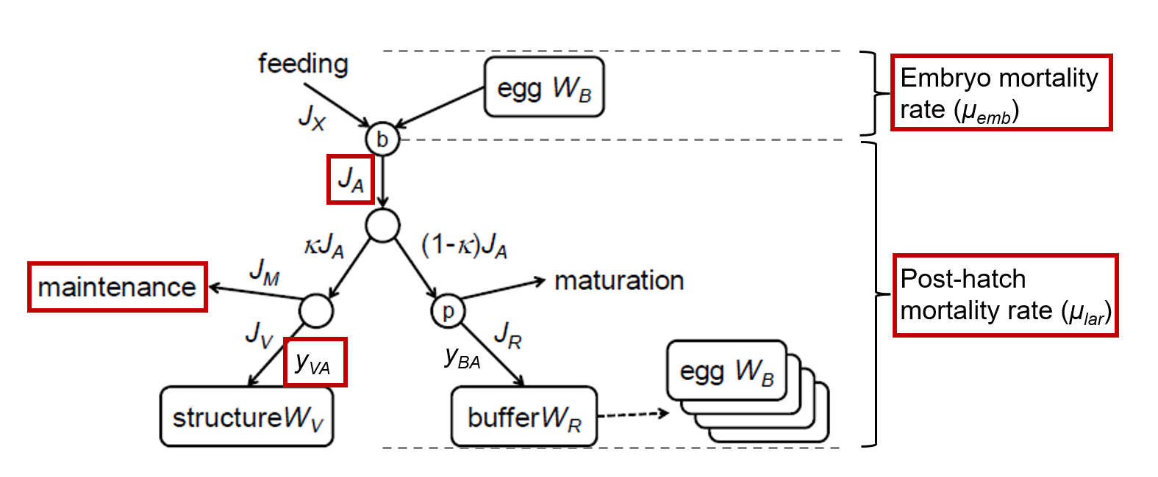

**Figure 1.** The DEBkiss model (diagram adapted from Jager et al., 2013) with stage-specific survival parameters used in this study. The candidate DEB processes for hypoxia stress mechanisms are highlighted in red boxes.

*Data*

For the base model we calculated and fitted parameters based on total length over time, initial egg buffer mass, time from fertilization to hatching (when egg buffer mass equals zero), cumulative egg production over time, and proportion surviving since fertilization over time. This allowed us to estimate length at puberty (*LVp*), which in this model is the length at the age at which egg production begins. We obtained *WB0* from *M. menidia* egg dry weight data (Klahre, 1997) and calculated *δM* and *dV* from total length, egg diameter, and egg mass data (Cross et al., 2019; Klahre, 1997; Concannon et al., 2021). We borrowed data on change in larval dry weight over a period of starvation from the closely related species *M. beryllina* (Letcher and Bengtson, 1993). We used the rate of decrease in dry weight during starvation to approximate maintenance costs (*JvM*). The total length data allowed us to estimate *JaAm* and *yVA* by adjusting these parameters to simulate a growth curve similar to the data, fix *JaAm* to a reasonable value based on ultimate length, then estimate *yVA* using the BYOM solver. All datasets came from experiments in which fish were fed *ad libitum* so *f* was set to 1.

Total length data came from three studies. Length at hatching and 15 days post-hatching (dph) came from a study that reared *M. menidia* offspring in three different static oxygen levels across two experiments (Cross et al., 2019). This provided data for control oxygen levels used in the base model and three reduced oxygen treatments. The study featured two additional studies that exposed offspring to fluctuating oxygen and carbon dioxide (CO2) levels but the control conditions were static, so we used total length data from these treatments for the base model as well (Cross et al., 2019). We sourced additional length data for the base model from control levels of experiments that exposed *M. menidia* offspring to ambient and elevated CO2 levels (Murray and Baumann, 2018; Murray and Baumann, 2020; Concannon et al., 2021). All total length data were obtained from fish maintained in static laboratory conditions at 24°C.

Cumulative egg production over time was also obtained from Concannon et al. (2021), a study in which wild-caught juveniles were held in the laboratory at 20°C in different CO2 treatments and strip-spawned once they reached reproductive maturity. We only used data from control fish. Data for time to hatching (i.e., time at which egg buffer mass is zero) and survival to hatching and 15 dph under different oxygen levels were obtained from Cross et al. (2019). We also used survival data from the 24°C and control levels of a study on the effects of different temperatures and CO2 levels on *M. menidia* early life survival from several experiments (Murray and Baumann, 2018). Four additional data points for long-term survival in laboratory conditions at 17°C were obtained from a study that exposed *M. menidia* offspring until 122 dph to two CO2 levels, of which we only used data from the control level (Murray et al., 2017).

**Table 1.** DEBkiss parameters, their abbreviations, and their fixed or estimated values. Units are given with the value unless the parameter is a unitless ratio.

|  |  |  |  |
| --- | --- | --- | --- |
| **Parameter** | **Symbol** | **Fixed or estimated** | **Value** |
| Max. area-specific assimilation rate | *JaAm* | Estimated | 0.333 mg mm-2 d-1 |
| Max. volume-specific maintenance rate | *JvM* | Fixed | 0.0214 mg mm-3 d-1 |
| Initial egg weight | *WB0* | Fixed | 0.15 mg |
| Total length at puberty | *LVp* | Fixed | 100 mm |
| Yield of assimilates on volume | *yAV* | Fixed | 0.8 |
| Yield of egg buffer on assimilates | *yBA* | Fixed | 0.95 |
| Yield of structure on assimilates | *yVA* | Estimated | 0.3646 |
| Fraction of assimilates allocated to soma | *κ* | Fixed | 0.8 |
| Scaled food level | *f* | Fixed | 1 |
| Scaled food level for embryo | *fB* | Fixed | 1 |
| Half-saturation total length | *Lf* | Fixed | 0 |
| Mortality rate for embryos | *μemb* | Estimated | 0.06393 |
| Mortality rate for larvae | *μlar* | Estimated | 0.02940 |

*Base Model Calibration*

We used experimental data on *M. menidia* and the closely related inland silverside *M. beryllina* to calculate core DEBkiss parameters, estimated three parameters by fitting them to data, and fixed parameters for which we had insufficient data to calculate or estimate at suggested values (Jager, 2018). The primary parameters and their calculated or estimated values are found in Table 1. Fitting was done in Matlab with the packages BYOM v.6.4 (Jager, 2022) and DEBkiss v.2.3a (Jager, 2021). BYOM uses a Nelder-Mead simplex search to optimize the parameters for a set of ordinary differential equations (ODEs) by minimizing negative log-likelihood. The DEBkiss package works under BYOM to bring in the DEBkiss model parameters, variables, and equations so that the parameters can be estimated based on their effect on the DEBkiss equations and the ODEs derived from them. The ODEs give the predicted data for each type of observed data (length, egg production, egg buffer mass, and survival over time) the difference between which is used to calculate negative log likelihood.

Before estimating any parameters with the optimization described above, we ran simulations of the predicted data with a set of default parameters and parameters sourced from existing data on *M. menidia*. We visually assessed fit and checked NLL as we adjusted parameters to obtain a reasonable set of initial parameters before estimating any. This also helped us reduce the number of parameters being estimated to avoid overfitting and so that there were not multiple correlated parameters free at once, because we were able to obtain a reasonable fit using suggested default values for *yAV*, *yBA*, and *κ*. The default value for *yVA­* did not allow a realistic fit to the length data, but the length, reproduction, and egg buffer depletion data allowed it to be estimated with the BYOM solver. We estimated *yVA* then fixed its value as the estimated value to estimate *JaAm*. Both of these parameters affect growth and egg buffer depletion so they could not be estimated simultaneously, but we did not have sufficient data to calculate them as we did *JvM*. Finally, we fixed all parameters except *μemb* and *μlar* to estimate these parameters, again using the visually best-fitting parameters from the simulations as initial values. The full-life and early-life predicted and observed data are shown in Figure 2.

*Hypoxia Stress*

We applied a stress function to several primary parameters (Figure 1) to attempt to explain observed differences in *M. menidia* length, hatching, and survival between experimental oxygen treatments (Cross et al., 2019). To summarize the experimental data on chronic hypoxia effects, the mean values of each data type for the different oxygen treatments are listed in Table 2. We used the parameter values from the base model that contained full life data and altered one or more parameters at a time with an oxygen-dependent stress variable, then fitted the model to data for only the first 136 days. We only used early life data to fit the hypoxia-altered parameters because we did not have late-life data for multiple oxygen treatments later in life to validate observed changes against and did not have any reproduction data for oxygen treatments. It did not make sense to include later life data in the calculations of NLL and AIC that influence the parameter estimates or to speculate about how well the predicted data match what we might expect to happen later in life if we not only lack late-life hypoxia data but also do not expect full life hypoxia to occur in nature.

The stress function calculated a stress variable (*s*) that increased linearly with DO between an upper and lower oxygen threshold, *A* and *B* (Figure 2):

The stress variable was applied to the parameter(s) of interest using functions that either increased or decreased the parameter with increasing stress, depending on the hypothesis for each parameter. To increase a parameter *p* each occurrence of the parameter in the model equations was replaced with:

To decrease a parameter *p* each occurrence of the parameter in the model equations was replaced with:

The parameters of interest we increased with the stress function were *JvM*, *μemb*, and *μlar*. The parameters we decreased with the stress function were *JaAm* and *yVA*.

Because the thresholds *A* and *B* affect the slope of the stress function and the location of the DO treatments within the window, changing *A* and *B* affected the fit to the data for each DO level as evidenced by the NLL in simulations (without estimation turned off). To find the best values of *A* and *B* for each parameter or combination of parameters according to NLL and AIC, we set *A* and *B* as primary parameters and estimated them. Once we found the best *A* and *B* for each parameter and pair of parameters, we compared the AIC between each stress function scenario to determine which one best fits the data and, therefore, which DEB processes best explain the hypoxia effects observed in experiments.

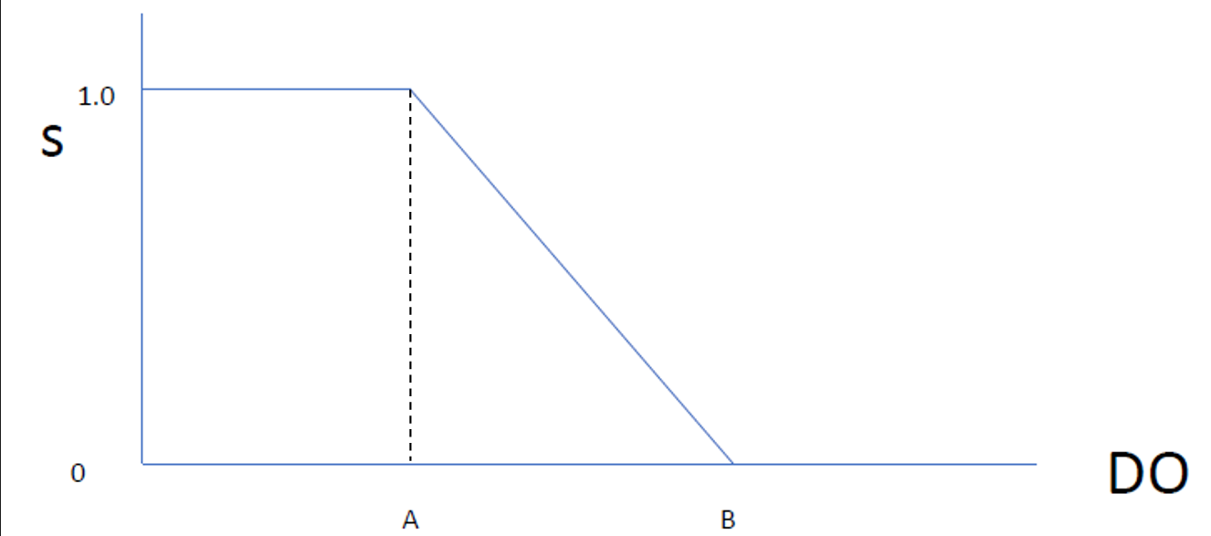

**Figure 2.** The increase in stress (*s*) from 0 to 1 with decreasing DO from upper threshold *B* to lower threshold *A*. This stress variable is implemented through functions to increase or decrease one or more parameters based on level of stress from DO.

**Table 2.** The mean survival to hatching, hatch time (at which egg buffer is zero), length at hatching, length at 15 dph, and survival to 15 dph from the different oxygen treatments in Cross et al. (2019). The control DO level means (7.7 mg l-1) also include data from Murray and Baumann (2018).

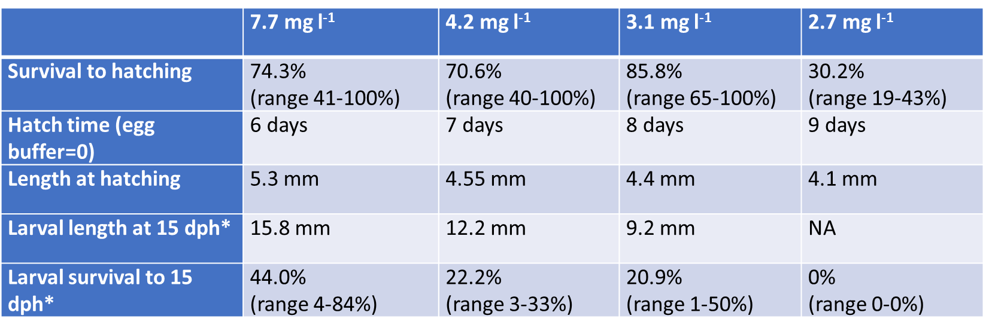

**Results**

*Base model*

We obtained realistic fits to all datasets. The only exception is late-life survival, for which the mortality was too high beyond the larval stage but could not be better fit due to lack of full-life survival data. However, this did not impair our ability to model the early life survival which are the stages in which we are interested in examining the hypoxia effects. Estimating *yVA* returned a lower than typical value for conversion efficiency of assimilates to growth, but this gave a realistic fit to the length data and allowed a detailed and very close fit to egg buffer depletion (time to hatch). The observed and predicted data for full life span and early life are plotted in Figure 3.

**Figure 3.** Full life (A) and early life (B) predicted and observed data for the base DEBkiss model of *M. menidia*.

**A.**

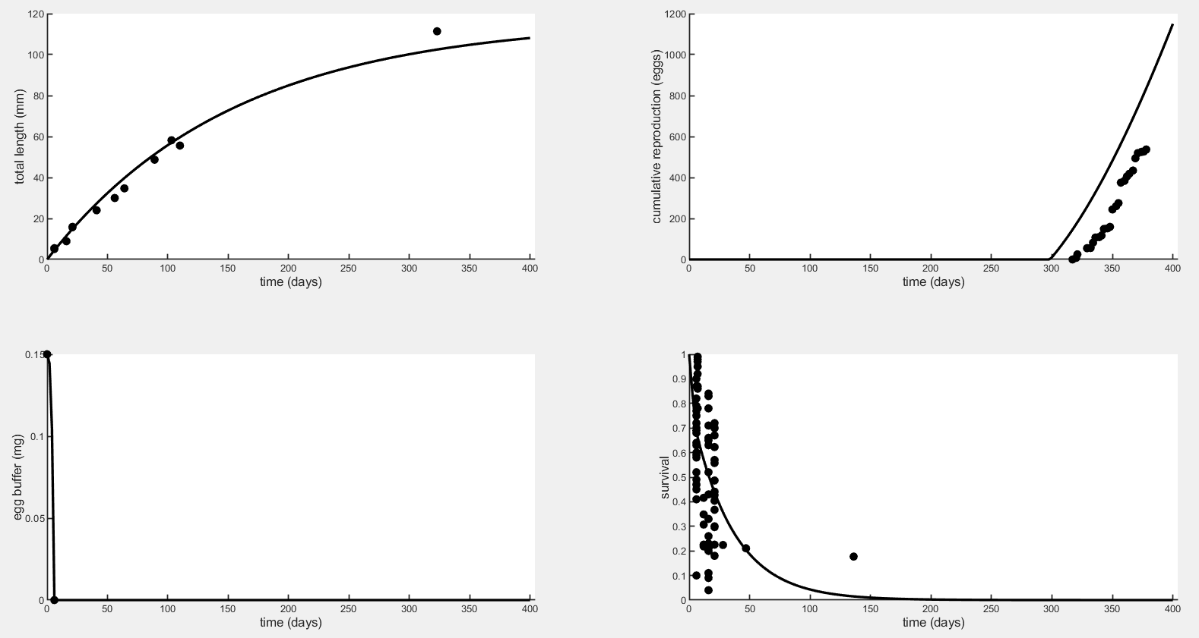

**B.**

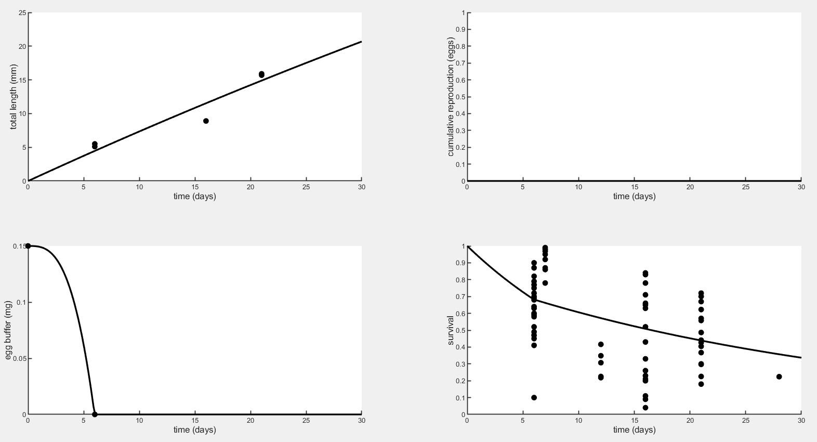

*Hypoxia Stress*

This is the part I am still working on but here is an example of how applying the stress function to each parameter affects the early-life fit. Changing the thresholds *A* and *B* affects how close together the different colored lines are.

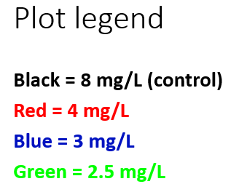

Assimilation (*JaAm*): affects growth, time to hatching, and (indirectly) hatch survival. Because of the two different mortality rates before and after hatching, changing the time to hatching also affects hatch survival.

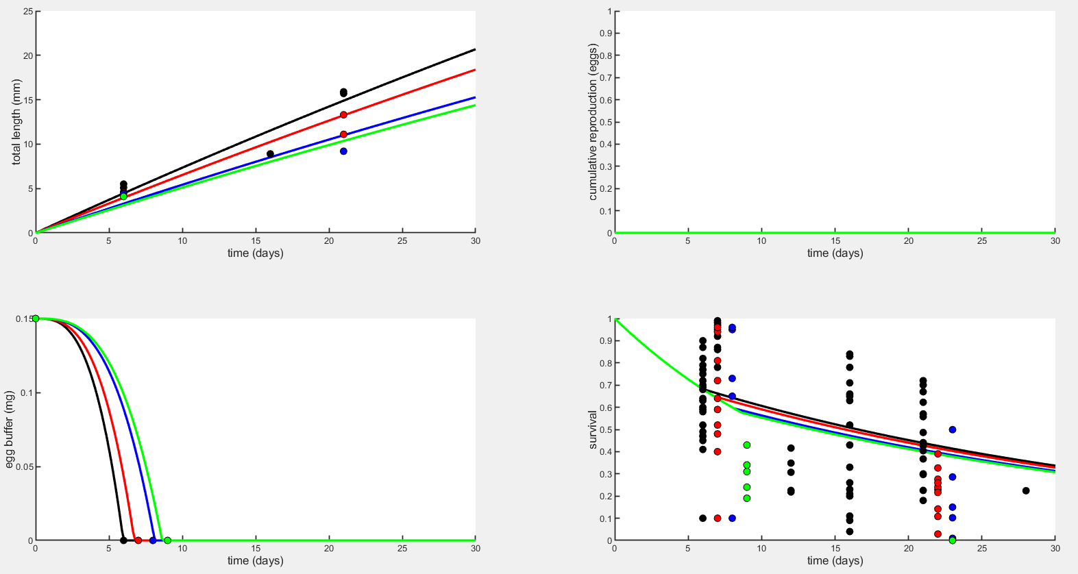

Conversion efficiency for growth (*yVA*): similar effect to assimilation.

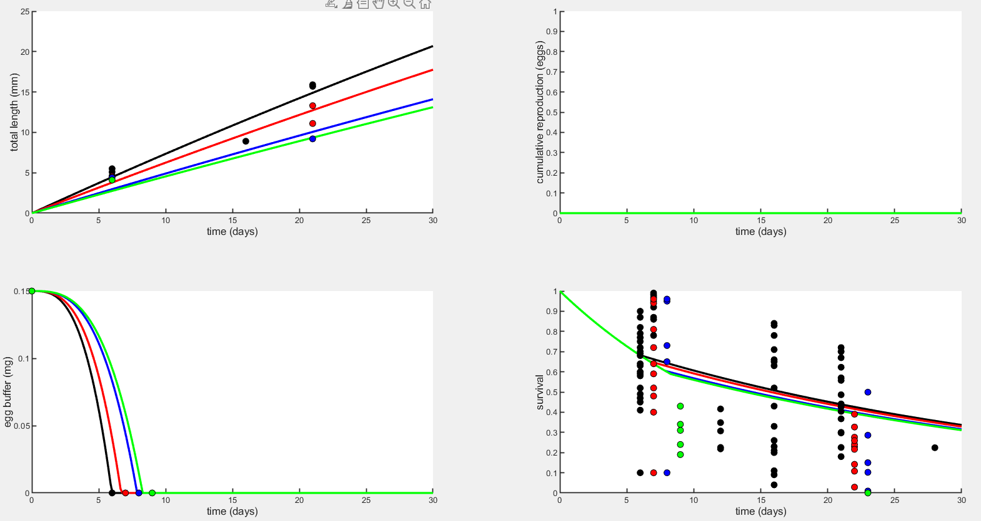

Maintenance (*JvM*): very mild effect on growth and nothing else, would have to increase by maybe unrealistic amounts to get effects seen in data.

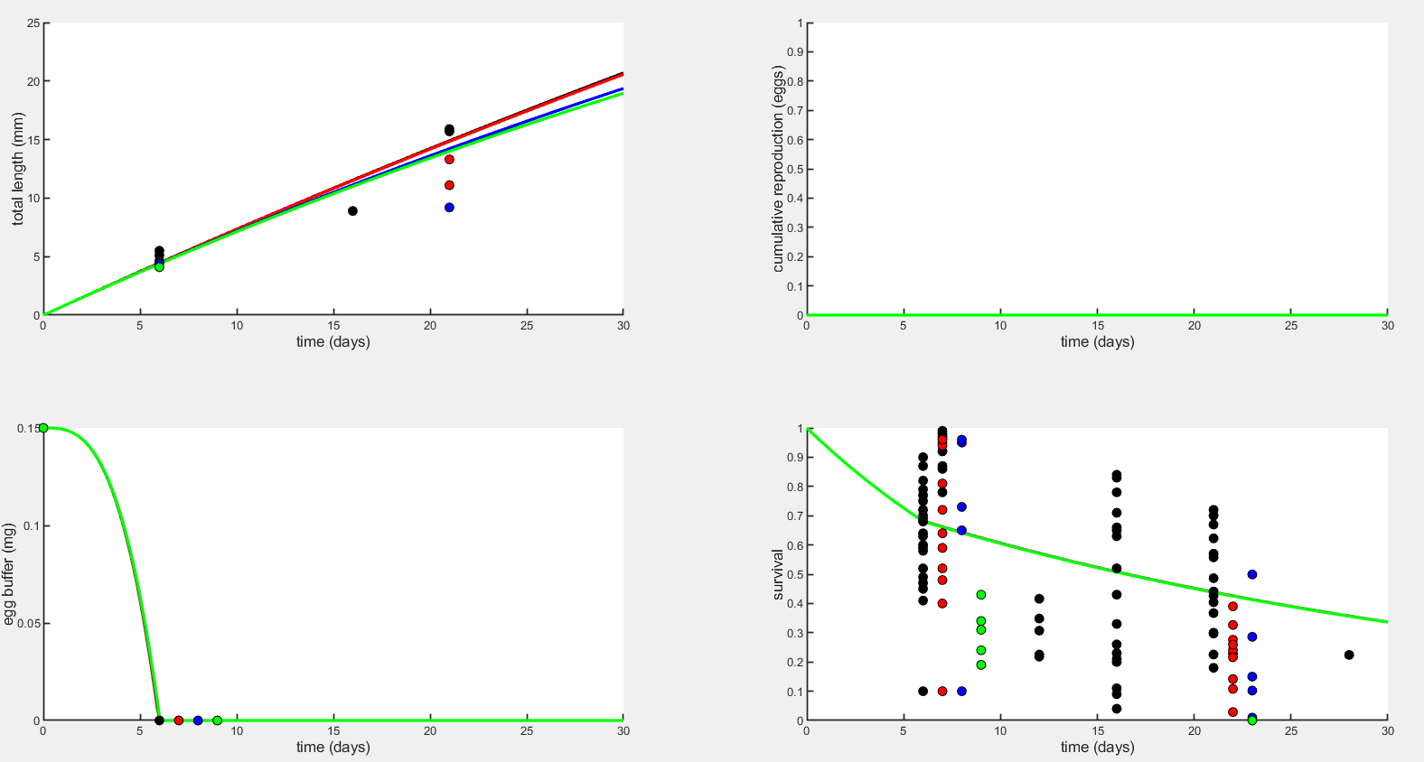

Embryo mortality (*μemb*): only affects survival to hatching, and doesn’t really get at a DEB mechanism because we are just telling mortality to go up rather than changing a metabolic process.

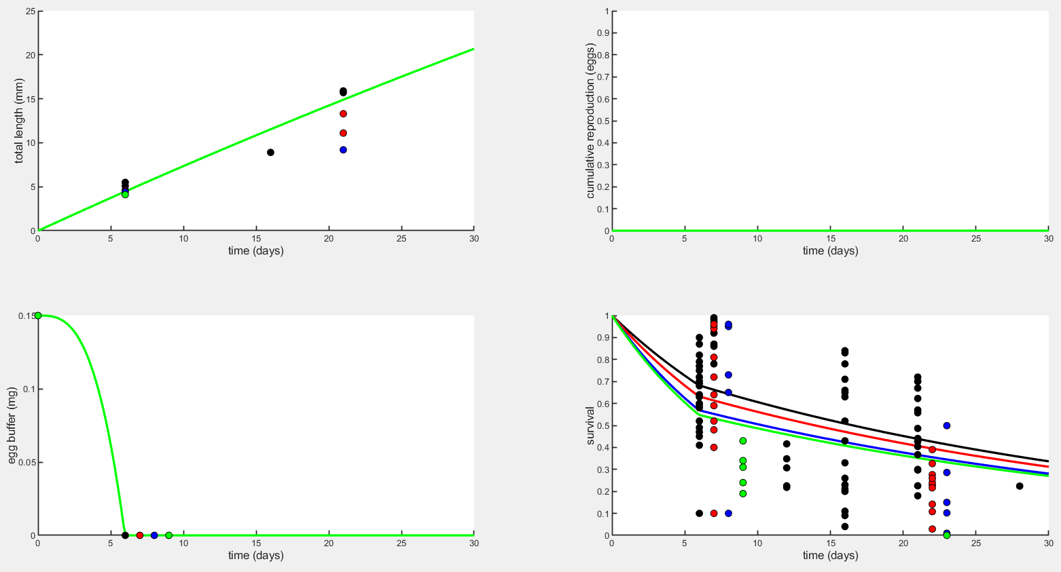

Larval mortality (*μlar*): Similar to embryo mortality, but also doesn’t explain why survival was zero at the lowest oxygen level (2.5 mg/L) because there is no combination of the thresholds *A* and *B* that get survival that low. 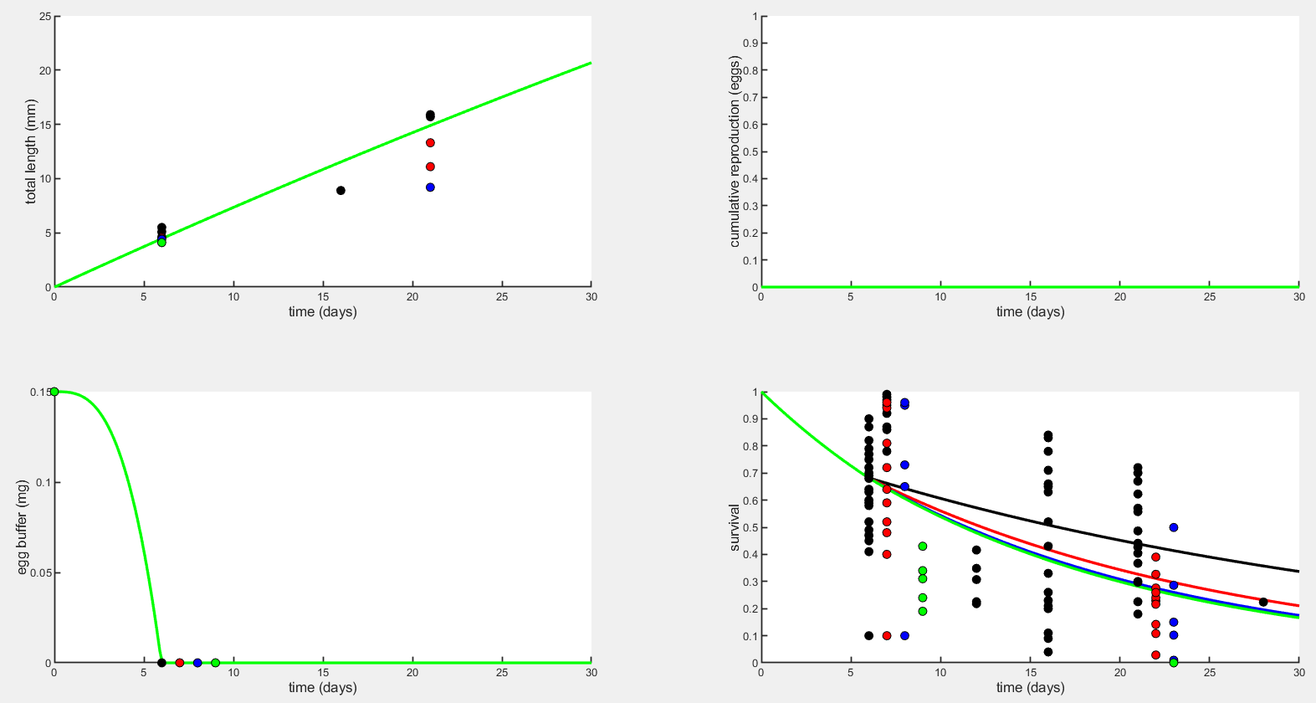

**References**

Jager et al 2013 – DEBkiss or the quest for simplest

Jager 2018 – DEBkiss book

Letcher and Bengtson 1993

Cross et al 2019

Concannon et al 2021

Klahre 1997

Breitburg et al 2018 – declining oxygen in coastal waters

Gruber 2011 – turning sour

O’Donnell et al 2004 – hypoxic zone in LIS

Baumann and Smith 2018 – pH and DO patterns in NERRs

Testa et al 2018 – Chesapeake Bay hypoxic zone

Farrell and Brauner 2009 – Fish Physiology Hypoxia

Zhu et al 2013 – Strategies for hypoxia adaptation in fish

Baumann, 2019 – ODV paper